Travel

You need to add 25 things to this document. (Make sure to number them just as I did in the example.) It may be helpful to copy and paste this list and then fill it in as you go along. All image names must start with your location, e.g yellowstone_sunset.jpg unless you are using a link from the internet.

1. Grand Canyon
2. Primary Image of Location as a gif
3. Primary Image of Location as non-gif.
4. Name of file with gif file (make sure to add the picture to the proper Google Drive!)
5. Name of file with non gif file (make sure to add the picture to the proper Google Drive!)
6. **Geographical Location**: Asia, Africa, North America, South America, Antarctica, Europe, Australia
7. Paragraph One about the location
8. Paragraph Two about the location.

For the next five pictures you can just put the names of the files, you don't have to include the files in this drive, but you do need to add them to the proper Google Drive.

1. **Photo Gallery – (Just write Photo Gallery)**
2. file name
3. Visual description of the image (leave image for movies)
4. Caption of the image/movie
5. file name
6. Visual description of the image (leave image for movies)
7. Caption of the image/movie
8. file name
9. Visual description of the image (leave image for movies)
10. Caption of the image/movie
11. file name
12. Visual description of the image (leave image for movies)
13. Caption of the image/movie
14. file name
15. Visual description of the image (leave image for movies)
16. Caption of the image/movie
17. Your Name

## image15.gifSofia, Bulgaria

1. 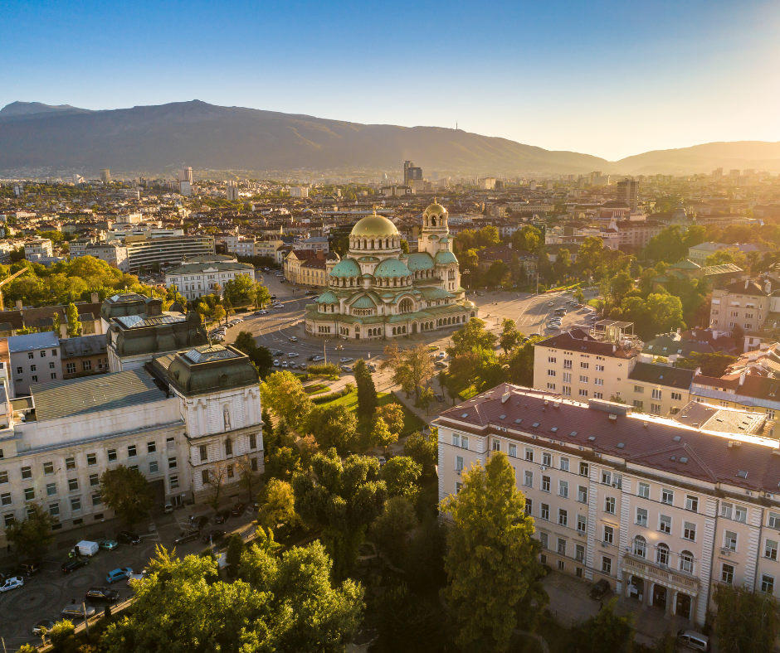
2. Sofia_Bulgaria.gif
3. Sofia_Bulgaria.jpg
4. **Geographical location:** Europe
5. Sofia is the capital city of Bulgaria, a country located in Eastern Europe. It is part of the European Union and the primary language spoken is Bulgarian. The city’s population is around 1.3 million. In addition to its urban structures, Sofia also contains a mountain peak called “Vitosha”.
6. Vitosha is located 30 minutes from the capital’s center, and can be reached by foot, car, and by lift. The peak has an elevation of 7,520 feet and during the summer months the average temperature is around 64 degrees fahrenheit. This makes it a great sight for any type of traveler who seeks the outdoors.
7. **Photo Gallery**
8. sofia_cathedral.jpeg
9. A picture of a cathedral with a sunset in the background.
10. Located in the city’s center, St. Alexander Nevsky Cathedral displays some of Sofia’s grand architecture.
11. sofia_center.jpeg
12. A picture of a crowded street with a mountain range in the background
13. Vitosha boulevard is often packed with both locals and tourists and contains shops, restaurants, live music, and great views.
14. sofia_peak.jpeg
15. A view of a city from the peak of a mountain during daytime.
16. The peak of Vitosha mountain offers a great view of Sofia from above.
17. sofia_street.jpg
18. A narrow street during sunset with locals walking and a public tram.
19. A picturesque street giving insight into the locals' lives and the city’s public transport trams.
20. sofia_brickroad.jpeg
21. A city street with yellow bricks and some locals walking.
22. One of Sofia’s famous roads, this street is paved with an interesting material: yellow cobblestones. Being one of the first streets in the entire city, it was first paved in 1907 and continues to be maintained to this day.
23. Alyna Petrov

## Paris, France

1. Primary Image of Location as a gif
2. Primary Image of Location as non-gif.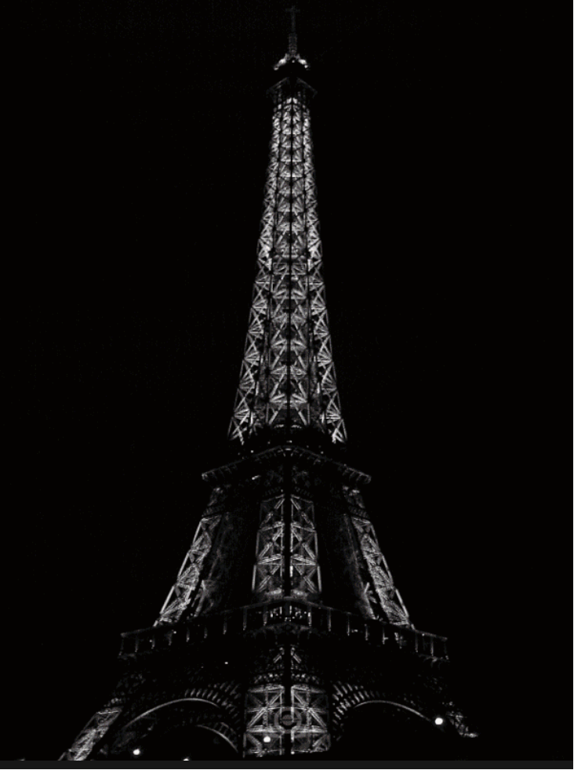
3. Name of file with gif file La_Tour_Eiffel.gif
4. Name of file with non gif file paris_nonjif_correct2.png
5. **Geographical Location**: Europe
6. Paris is one of the oldest cities in Europe and the city of romance. With a vast amount of cultural history, lined with iconic landmarks, intimate scenes, and world-renowed art museums.
7. Paris welcomes millions of visitors annually, each drawn to its exquisite charm and beautiful ambiance. Enjoy tasty treats and exquisite cuisine await, while city landmarks illuminate the night sky.

For the next five pictures you can just put the names of the files, You don't have to include the files in this drive, but you do need to add them to the proper Google Drive.

1. **Photo Gallery – (Just write Photo Gallery)**
2. paris_champs_elysees.jpg
3. Champs Elysées, on a street, slightly cloudy in Paris, France
4. Champs Elysées / Arc of Triumph
5. paris_eiffel_tower.jpeg
6. Eiffel tower in front of a clear blue sky, taller structure in Paris, France
7. Eiffel tower
8. paris_notre_dame.jpg
9. Notre Dame Cathedral with people viewing it in front of a lightly cloudy sky in Paris, France
10. Notre Dame Cathedral
11. paris_louvre_gallery.jpg
12. The Louvre Museum lit up in the night in Paris, France
13. The Louvre Museum
14. paris_palace_of_versailles.jpg
15. Palace of Versailles with gardens in front of it on a lightly cloudy day in Paris, France
16. Palace of Versailles
17. Anthony Tenn

## Zermatt, Switzerland

1. 

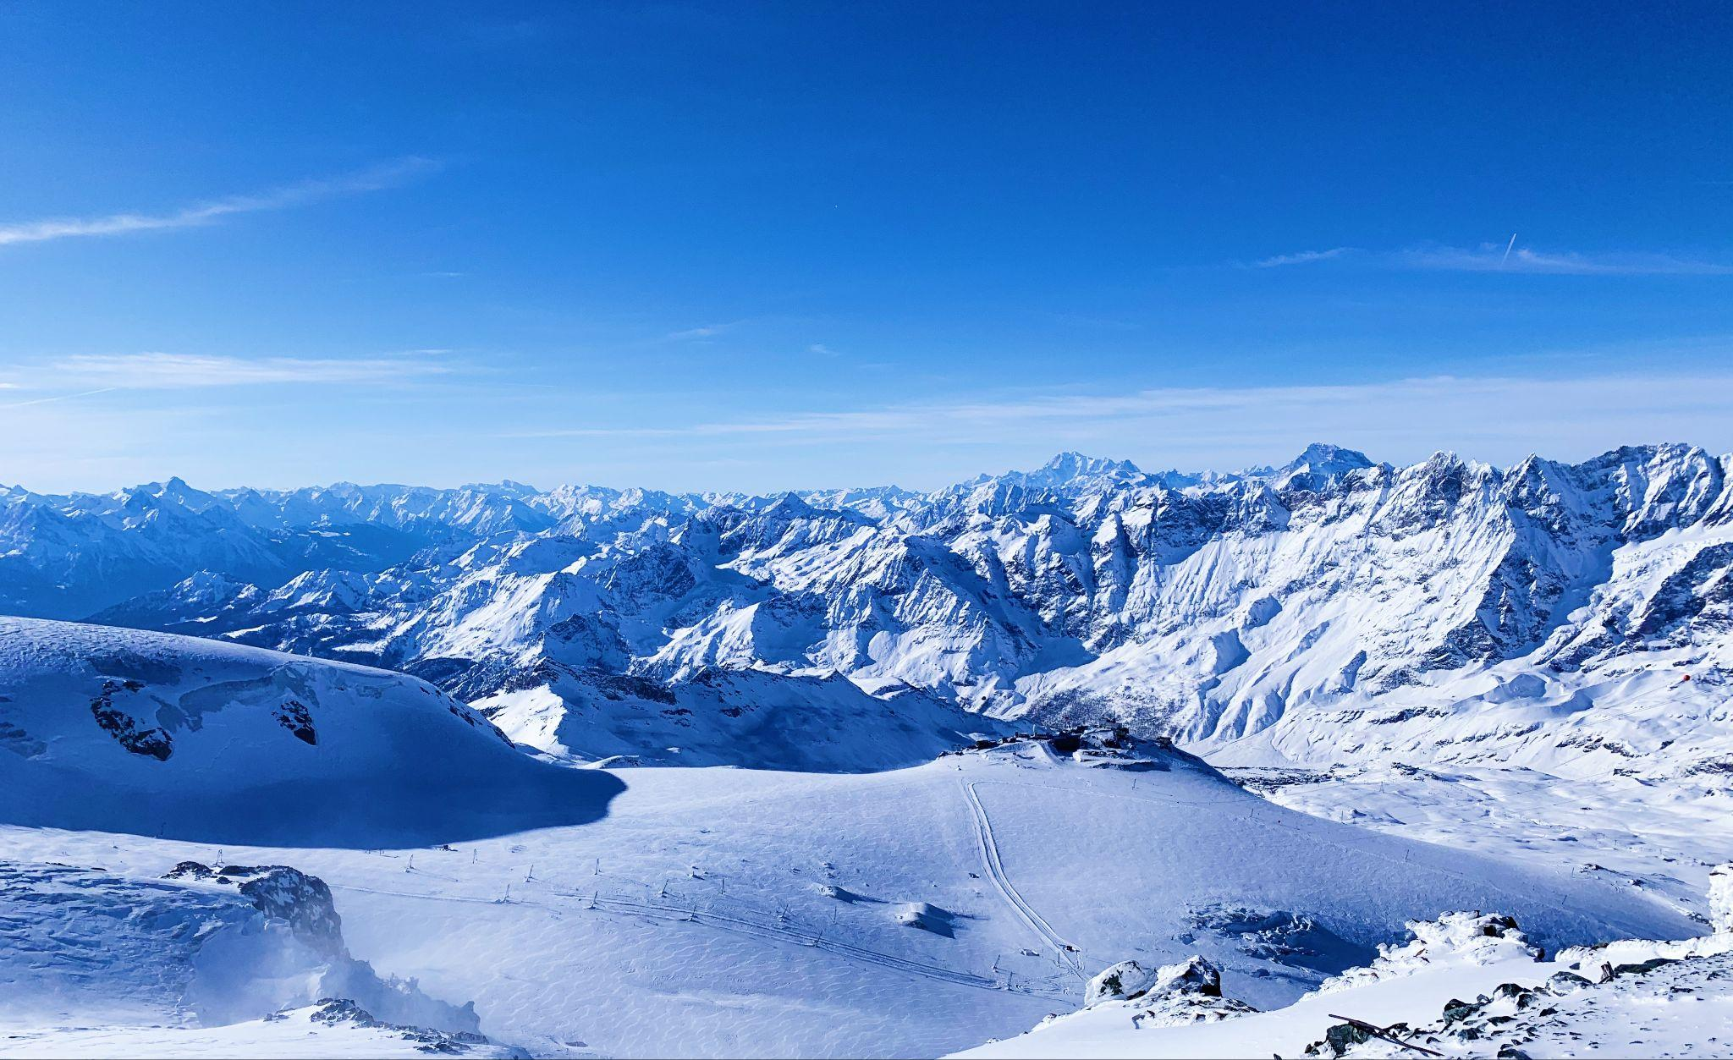

1. Zermatt_skier.gif
2. Zermatt_skyline.jpg
3. **Geographical Location**: Europe
4. Zermatt is a beautiful place, with 365 degree views of the mountains. It’s known for its famous mountain “the Matterhorn,” which is visible from nearly everywhere in the town. The town is vibrant, filled with patrons walking around, shopping for the most high quality snow boots, eating hot Rosti and drinking wine.
5. The skiing in Zermatt is unparalleled. Every day in the winter you can find people skiing all day. When it snows, the mountain becomes even more crowded, with skiers flocking to the mountain from around the country and the world.

For the next five pictures you can just put the names of the files, you don't have to include the files in this drive, but you do need to add them to the proper Google Drive.

1. **Photo Gallery – (Just write Photo Gallery)**
2. River.jpg
3. The river flows through the rocks and under the bridge into the town.
4. River flowing through Zermatt.
5. Summer_town.jpg
6. On sunny days in the summer the grass could not be greener in Zermatt, displaying all of the town’s colors.
7. View of the Zermatt town in the summer.
8. Matterhorn_clocktower.jpg
9. The sunset lights up the matterhorn and clocktower, exposing its beauty.
10. The matterhorn and clocktower at dusk.
11. Day_town_foot.jpg
12. A view on the ground in Zermatt’s town, revealing its energy and culture.
13. Zermatt on the ground.
14. Night_town.jpg
15. At night the town of Zermatt lights up, remaining energized.
16. Zermatt at night
17. Maya Rosenthal

## Dubai

1. 
2. 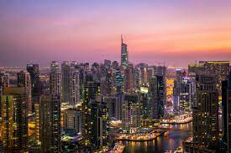
3. dubai_gif.gif
4. dubai_jpg.jpg
5. **Geographical Location**: Asia
6. Dubai, a city known for its impressive structures like Burj Khalifa and Palm Jumeirah, combines advanced technology with modern architecture. The city hosts Dubai Internet City, where big tech companies and startups collaborate, aiming to become smarter by using technologies like blockchain to enhance government processes. Additionally, Dubai's plans to implement 3D printing for constructing buildings represent a major step into the future.
7. Exploring Dubai means not only admiring its remarkable buildings but also understanding how it leverages technology to transform operations. The city's approach encompasses both architectural marvels and innovative tech solutions, making it an exciting prospect for individuals curious about the intersection of technology and urban development.

For the next five pictures you can just put the names of the files, you don't have to include the files in this drive, but you do need to add them to the proper Google Drive.

1. **Photo Gallery – (Just write Photo Gallery)**
2. dubai_travel.JPG
3. Beatiful skyline of dubai in the nighttime that is a once in a lifetime view.
4. Dubai NIghttime Skyline
5. dubai_burj_khalifa
6. A tall curved building amongst a blue sky background in the city
7. This is one of the tallest buildings in the world. With its impressive architecture and height, the Burj Khalifa stands as a marvelous tourist attractions in Dubai.
8. dubai_boat_ride.JPG
9. A tourist attraction where people can ride boats around Dubai.
10. Dubai Canal Boat Ride
11. dubai_dune_buggy
12. A dune buggy riding rapidly across sand dunes
13. The sand dunes that beautifully shape the Dubai landscape are commonly utilized as bumpy and exciting terrain for people looking for a wild ride on a dune buggy.
14. dubai_luxury_cars.JPG
15. Car company with many luxurious cars for rental in Mariana
16. Dubai Marina Luxury Cars
17. Dilan Swami and Bocar Soumare

## Rome, Italy

1. 

<https://gfycat.com/gloomybruisedadamsstaghornedbeetle>

1. 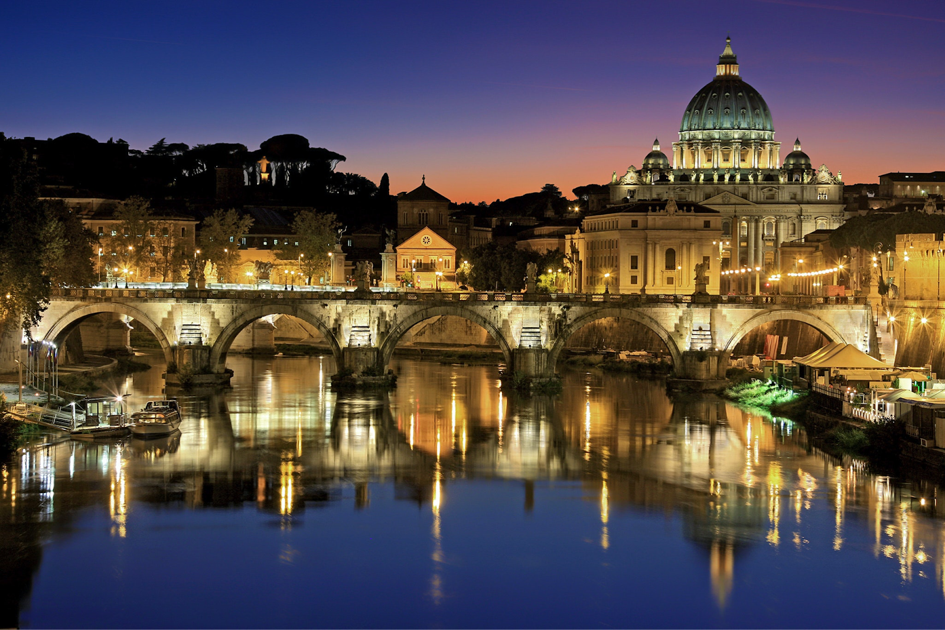

<https://italy4real.com/historic-sights-in-rome-that-everyone-should-visit/>

1. rome_gif.gif
2. rome_picture.jpeg
3. **Geographical Location:** Europe
4. The national capital of Italy remains a historical and political hub today. Nicknamed the “Eternal City,” Rome is considered the origination of the Catholic Church and Roman civilization central to the development of the Western World. Divided into 22 walled *rioni* (districts) surrounded by 35 *quartieri* *urbani* (urban sectors) that are surrounded by 6 large *suburbi* (suburbs), the city, just larger than New York City at an area of 496 mi2, is home to 2.8 million residents. Its economy runs on the tourism and services industries, the latter mostly in government jobs.
5. The Via del Corso, named after Roman carnival horse races, is the main street that runs through Rome. Many significant churches, palaces, and squares run along this road (Piazza del Popolo, and the Spanish Steps in Piazza di Spagna, for example). The seven hills that surround Rome are trenched with mythological history which can be seen through the prevalence of temples. Must see landmarks for those traveling include the Colosseum, Roman Forum, Pantheon, and Catacombs. St. Peter’s Square & Basilica and the Sistine Chapel, technically located within Vatican City – an independent city-state within Rome – are also worth a visit.
6. **Photo Gallery**
7. rome_map.jpeg

[https://stock.adobe.com/search?k=%22rome+map%22](https://stock.adobe.com/search?k=%2522rome+map%2522)

1. Simple depiction of the location of Rome within Italy.
2. Rome is located in the western-central region of Italy, about 15 miles inland from the neighboring Tyrrhenian Sea.
3. rome_map_2.jpeg

<https://ontheworldmap.com/italy/city/rome/>

1. Map portraying important attractions and landmarks as well as the layout of the city.
2. Nested within the Tiber river, the seven hills of Rome both give rise to another nickname and mark the ancient boundaries of the city.
3. rome_colosseum.jpeg

<https://fullsuitcase.com/colosseum-rome-italy/>

1. Peaceful image of Roman Colosseum at sundown with blue skies and sun rays shining through the background.
2. Built in 80 AD, the Colosseum was built as an amphitheater for entertainment, and hosted gladiatorial combat and animal fights for over 400 years.
3. rome_catacombs.jpeg

<https://www.tickets-rome.com/catacombs-tours/about/>

1. Arched, partially lit underground tunnels comprise the Catacombs of Rome.
2. Because of ancient Roman law dictating the deceased not to be buried within the city, the labyrinthian tunnels of the Catacombs of Rome stretch for over 12 miles outside city limits.
3. rome_pantheon.jpeg

<https://www.britannica.com/topic/Pantheon-building-Rome-Italy>

1. Painting of the interior of the Pantheon.
2. The largest domed temple built in its time, the interior of the Pantheon is illuminated by natural light flowing through a circular oculus and features colored marble and vast columns.
3. Iris Ding

## Machu Picchu, Peru

1. 
2. 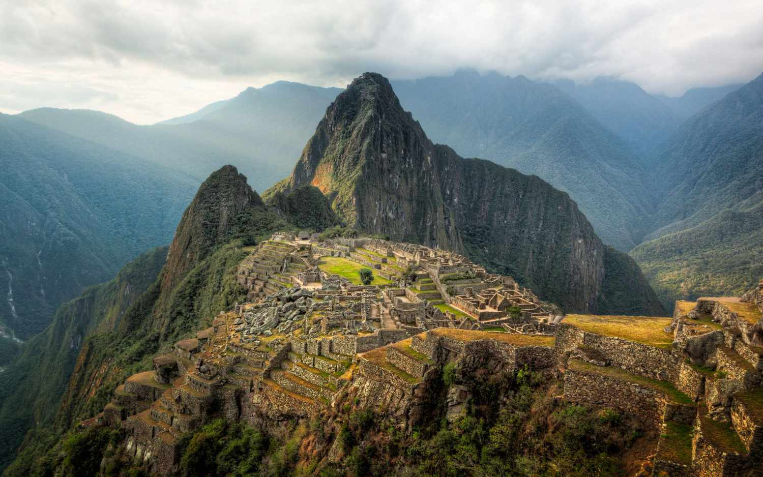
3. Machu Picchu_gif
4. Machu Picchu_nongif
5. **Geographical Location**: South America
6. Machu Picchu is an ancient Incan citadel located in the Andes Mountains of Peru, South America. It is renowned for its breathtaking beauty, architectural ingenuity, and historical significance. Believed to have been built in the 15th century during the height of the Inca Empire, Machu Picchu served as a royal estate or religious retreat for the Incan ruler Pachacuti.
7. Machu Picchu's remote location and mysterious abandonment in the decades following its construction have contributed to its status as a UNESCO World Heritage Site and one of the New Seven Wonders of the World. The site is characterized by its well-preserved stone structures, including temples, plazas, residential buildings, and intricate terraces carved into the mountainside. The precise construction methods used to build Machu Picchu without the use of mortar have puzzled archaeologists for decades. The entire complex is surrounded by stunning panoramic views of the surrounding valleys and mountains.
8. **Photo Gallery – (Just write Photo Gallery)**
9. machu_picchu_summer.jpg
10. A view of Machu Picchu with flowers and greenery in the foreground. Huayna Picchu is visible in the background.
11. Summer view
12. machu_picchu_couldy.jpg
13. A dark and moody view of the Machu Picchu ruins on a cloudy day. The Inca terraces are covered in bright green grass and the Huayna Picchu Mountain looms in the background.
14. Cloudy Machu Picchu
15. machu_picchu_llama.jpg
16. A llama walks around the ruins in a fenced off area. The llama is dark and light colored. The view of Machu Picchu is cloudy but visible.
17. Llama in ruins
18. machu_picchu_foggy.jpg
19. A wide shot of the stone architecture and Inca walls leading up to the Guardhouse. The fog is sitting in the ruins.
20. Foggy day in ruins
21. machu_picchu_huayna.jpg
22. A view of the famous Huayna Picchu Mountain and the ruins atop it. The main ruins of Machu Picchu are also visible in the lower half of the photo.
23. Huayna Picchu Mountain
24. Tiying Li

Travel

You need to add 25 things to this document. (Make sure to number them just as I did in the example.) It may be helpful to copy and paste this list and then fill it in as you go along. All image names must start with your location, e.g yellowstone_sunset.jpg unless you are using a link from the internet.

## Harbin





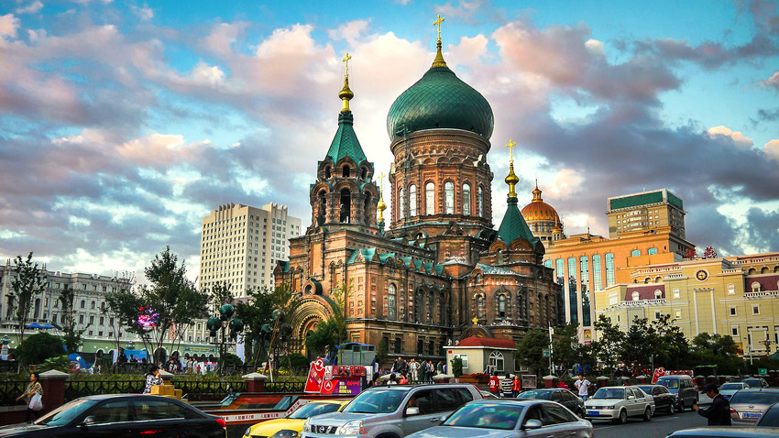

1. Harbin_gif.gif
2. Harbin_city.jpg
3. Asia
4. Harbin, often referred to as the "Ice City," is the capital of Heilongjiang Province in northeastern China. It has beautiful winter landscapes and Russian-influenced architecture, and the city serves as a major cultural and economic hub in the region. Established in the late 19th century as a fishing village near the Songhua River, Harbin quickly transformed into a vibrant cosmopolitan center, particularly due to the construction of the Eastern Chinese Railway by Russian engineers.
5. Today, Harbin is most famous for its annual International Ice and Snow Sculpture Festival, where colossal ice sculptures and intricate snow art transform the city into a winter wonderland. Harbin is also famous for its unique Russian foods including the Russian sausages and beer. It is a unique blend of Chinese and Russian cultures.
6. Photo Gallery
7. Saint_chapel.jpg
8. This is the daytime view of Saint Sophia’s church. With its distinctive green domes, golden crosses, and intricate frescoes, the cathedral is an architectural gem that harkens back to Harbin's past when the city was a meeting point for Chinese and Russian cultures.
9. Saint Sophia's Church
10. Ice_sculpture_festival.jpg
11. This is the center of the world's largest ice sculpture festival. People make amazing ice sculptures such as the castle in the picture every year.
12. Ice sculptures in the ice sculpture festival
13. central_street.jpg
14. This is the largest commercial street in Harbin. This pedestrian-only avenue is lined with an array of historic buildings that showcase a unique blend of Russian, French, and other European influences.
15. Central Street
16. ice_sculptures_night.webp
17. This is the night view of the beautiful sculptures in Harbin. During the winter, people build these ice sculptures and use light to decorate these amazing buildings in the night.
18. Ice sculptures in night
19. Harbin_institute_of_technology.jpg
20. Harbin Institute of Technology is one of the top universities in China. It is famous for its engineering and science research.
21. Harbin Institute of technology
22. Yanghe Liu

## 1. Dublin, Ireland

2.



3.

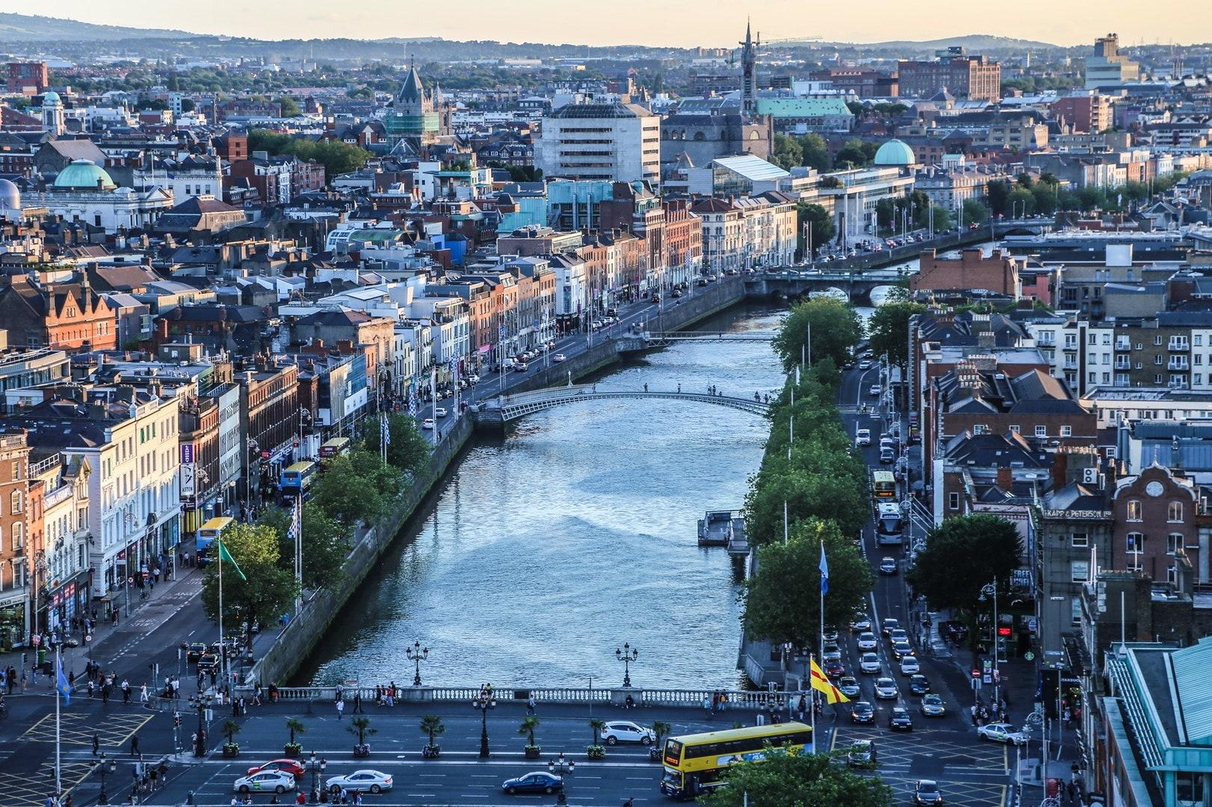

4.dublin_city.gif

5.dublin_city.jpg

6. **Geographical Location:** Western Europe

7. Dublin City is the capital city of the Republic of Ireland and is located in the east of Ireland. Dublin was originally a Viking settlement called Dubh Linn which translates to black pool. Dublin has always been a historically significant city in Irish history, from being the main city from which the British ruled over Ireland for 800 years to then being the setting of the 1916 Easter Rising and Irish War of Independence.

8. Today Dublin is a developed city boasting one of the strongest tech sectors in Europe and a booming tourism industry. Dublin is renowned for its sites such as the GPO, Croke Park, O'Connell Street, Temple Bar and Saint James Gate, which is where Guinness is brewed. Dublin is also surrounded by great coastal towns such as Dun Laoghaire, Howth and Skerries.

**9.Photo Gallery**

10. gpo.jpg

11.The GPO

12. Used in the 1916 Easter Rising as a rebel holdout. Scars from the battle such as bullet holes are still visible on its pillars today.

13. croke_park.jpg

14. A packed Croke Park

15. Croke Park is Ireland's largest stadium, known for hosting the All-Ireland football and hurling finals annually. It has a capacity of 82,300 making it the 4th largest stadium in Europe.

16. oconnell_st.jpg

17. Bustling O’Connell Street

18.O’Connell Street is Ireland’s main street. It’s named after Daniel O’Connell, an Irish politician who fought for the unrepresented Irish catholics to have a voice in the British parliament whilst Ireland was still under British rule. A statue was built in his honor at the end of the street.

19. temple_bar.jpg

20. Temple Bar

21. Temple Bar is an area of Dublin City Centre that is named after the world famous pub, the Temple Bar. It is a tourist hotspot and is the only pub in Ireland where you will not find a single Irish person. It is also known to have one of the most expensive pints of Guinness in Ireland.

22. st_james_gate.jpg

23. Saint James’s Gate

24. Saint James’s Gate is where Guinness is brewed. You are able to do a tour of the facility to see the history of Guinness, how Guinness is brewed and have a pint right from the source.

25. Dylan Geraghty

## Seoul, South Korea

1. 
2. 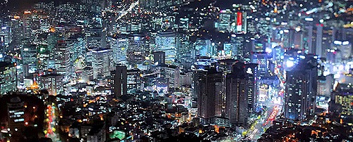
3. seoul1.gif
4. seoul1.jpeg
5. **Geographical Location:** Asia
6. Seoul is the capital of South Korea and it is a city enshrined in history. The Han river runs through Seoul, dividing it into two parts. Additionally, there are many mountains in and around Seoul, making it so the city has a lot of hills.
7. Seoul is the perfect blend of modern and historical with five royal palaces and several shrines. Additionally, there are plenty of fun shopping areas in Seoul such as Hongdae, Insadong, and Gangam. Lastly, Seoul is a city of cafes with one on almost every block and several fun cafe experiences to try out, especially in Yeonnam.
8. **Photo Gallery**
9. namsan.jpg
10. A tower on a hill overlooking the city
11. Enjoy panoramic views of Seoul from Namsan Tower.
12. hongdae.jpg
13. A colorful street at night with people walking down it.
14. With tons of interesting stores, Hongdae is a great place to shop and experience the nightlife.
15. gyeongbokgung.jpg
16. A palace sits in front of mountains.
17. Learn about the history of Seoul and visit Gyeongbokgung palace, one of the many palaces Seoul has to offer.
18. gwangjang.jpg
19. A vibrant market with lots of people in it.
20. Try Korean street food for a low cost by visiting Gwangjang market.
21. ikseondong.jpg
22. A small street running through traditional style buildings.
23. Go to Ikseondong to try several unique cafes and stroll around traditional hanok style buildings.
24. Claire Callen and Malwine Fischer